***Practical assignment. Try out Google Drive and the apps on it***

1. Explore the *Google* Drive environment. Then create a Digital Literacy Works folder and upload some files from your computer to it

2. Using *Google* Drive, create and design the text document below

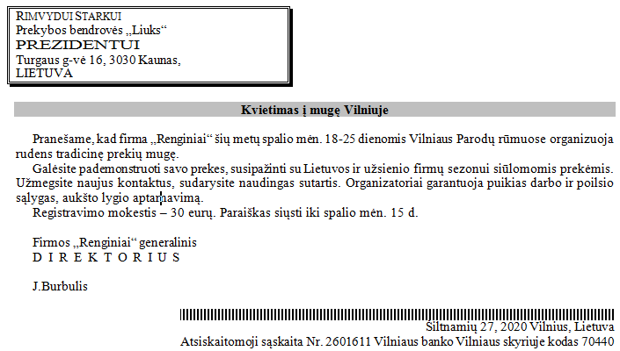

3. Create the table below using *Google* Spreadsheet and calculate the value:

