***Practical assignment. Create an email account***

If you want to use Gmail, create a Google account. "You can use your Google Account username and password to sign in to Gmail and other Google products such as YouTube, Google Play and Google Drive.

Follow the video instructions to create an account and a Gmail email (create a video using this example)

<https://youtu.be/MQUav0KJpgg?si=qD-c-8y9M7LDnoFF>

Once you've done that, your email will open.

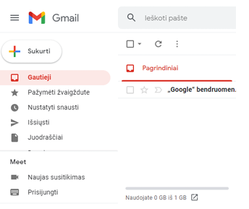

To create an email, click the **Create** button. A window will open where you need to enter the email address(es) (e.g. vardenispavardenis@gmail.com) to which the email is to be sent and the subject (e.g. Greetings). In the window below, you can now write the text that will be sent to the specific recipient. At the bottom of the window you will find the necessary text formatting tools and the **Send** button, which is clicked when the letter is edited. Various documents can be attached to the letter. To do this, click on the button and select the file you want to send from the window of files stored on your computer.

Get the email addresses of your family and friends and send a text message to some of them, and a text message with a photo or document attached to it.

In the letter, tell them to write back to you and also attach a picture or document.

When you receive an email, it is highlighted, just click on it with your mouse, read it and write a reply by clicking on the **Reply** button or send it to others by clicking on the **Forward** button.

