***Practical assignment. Try Google Chrome* and *Google* Search**

First, install *Google Chrome on* your computer (installation address) according to this video <https://youtu.be/QIX8JhhPtKI?si=dnEpE2Q3OResFwSF>

(make a video based on it).

Now test the software you have installed with the tasks below:

1. Type [www.lrytas.lt](http://www.lrytas.lt) in the top address box of *Google Chrome*, press ENTER and view the electronic version of this newspaper.



Then enter the following addresses: www.swedbank.lt, www.knygos.lt, [www.lvb.lt](http://www.lvb.lt) and explore these sites.

2. Enter the keywords *e-Citizen courses* in the *Google* search box*,* press the ENTER key and see what information is displayed.

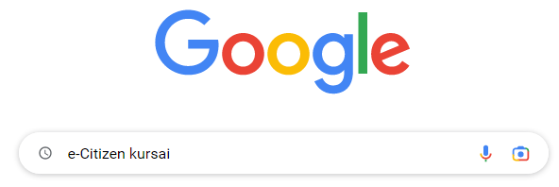

2. Type the keyword *computer* in the *Google* search box, then press the ENTER key. Select the *Images* tab at the top and view the visual information provided.

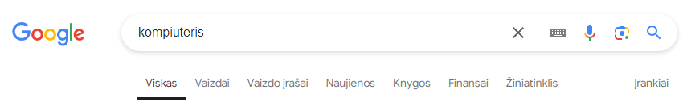

3. In the *Google* search box, type the keywords *for a video about using a computer*, then press the ENTER key. Select the *Videos* tab at the top to see what videos are available on this topic.

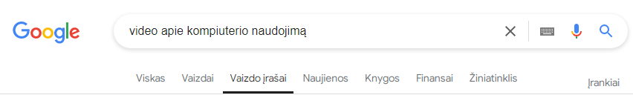

4. Enter the keywords *bird sounds* in the *Google* search box, press the ENTER key and view the information.

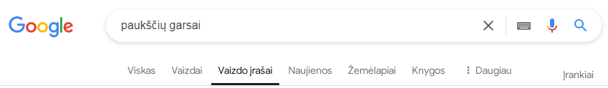

After completing the task, think about whether you liked using *Google Chrome* and whether you intend to use it as your main browser on your computer or mobile device.